**PROJECT PROPOSAL: MOBILE HEALTH APP**

**PROJECT TITLE**

**Mobile Health Application for Accessible and Efficient Healthcare Services**

**DEVELOPMENT TEAM**

**- Joshua Ralph Baawa**(Lead Developer)

**- Anton Palayad**   
(Developer)

**- Justin Camilo**   
(Developer)

**STAKEHOLDERS TEAM**

**- Adji Lawad**   
(Healthcare Partner)

**- Jay Mark Quinagoran**(Healthcare Partner)

**- Lorie Ann Viloria**  
 (Healthcare Partner)

**I. GOAL**

The primary goal of this project is to develop an innovative and user-friendly mobile health application that enhances healthcare accessibility and efficiency. The app will serve as a digital healthcare platform that allows users to consult doctors, book medical appointments, access health records, and receive timely health notifications. By integrating technology with healthcare services, the application aims to improve patient care, streamline medical consultations, and promote overall well-being.

**II. OBJECTIVES**

1. To develop a mobile application that enables users to schedule appointments with healthcare professionals efficiently.

2. To provide a secure platform for users to store and access their medical records digitally.

3. To integrate telemedicine services, allowing users to consult healthcare professionals remotely.

4. To include health monitoring features that track vital signs and provide wellness insights.

5. To ensure data security and compliance with healthcare regulations for protecting user privacy.

6. To promote health awareness through timely notifications and educational resources.

**III. TARGET USERS**

**1. Patients** – Individuals seeking easy access to medical consultations and health records.

**2. Healthcare Providers** – Doctors and medical staff who will use the platform for patient management.

**3. Clinics and Hospitals** – Medical institutions that can integrate the system into their operations.

**4. Health Enthusiasts** – Individuals looking to monitor their health and receive wellness guidance.

**IV. EXPECTED FEATURES**

**For Users:**

1. User Registration and Secure Login

2. Online Appointment Booking

3. Telemedicine (Video/Chat Consultation)

4. Personal Health Records Management

5. Health Monitoring and Alerts

6. Prescription and Medication Reminders

7. Emergency Contact and Assistance Feature

**For Healthcare Providers:**

1. Doctor Profile and Availability Management

2. Patient Records Access and Update

3. Virtual Consultation Scheduling

4. Prescription and Medical Advice Issuance

5. Reports and Analytics for Patient Health Trends

**V. DATA GATHERING METHODS**

The development team will collect data through:

**1. Surveys**- Gathering user needs and expectations from potential patients and healthcare providers.

**2. Interviews** - Consulting doctors and medical professionals for insights on essential features.

**3. Observational Research** - Analyzing existing healthcare applications and their functionalities.

**4. Usability Testing**- Conducting trials to refine and enhance user experience.

**VI. TOOLS AND TECHNOLOGIES TO BE USED**

**1. Programming Languages**: Flutter (Dart), Java/Kotlin (Android), Swift (iOS)

**2. Database Management**: Firebase, MySQL

**3. Cloud Services:** AWS, Google Cloud

**4. Security Protocols:** HIPAA Compliance, Data Encryption

**5. UI/UX Design**: Figma, Adobe XD

**VII. EXPECTED OUTCOME**

The successful development of this mobile health application will bridge the gap between patients and healthcare providers, ensuring better healthcare delivery. The app will provide a convenient, secure, and efficient healthcare experience while leveraging modern technology for improved accessibility and medical service efficiency.

CONTACT DETAILS

Email: [healthapp.devteam@gmail.com](mailto:healthapp.devteam@gmail.com)

Phone: 09157640622

Address: Purok 6, Bulanao, Tabuk City, Kalinga

**MANDATE**

To improve healthcare services through digital innovation by providing a reliable, user-friendly, and secure mobile health application that connects patients with healthcare professionals, streamlines appointment scheduling, and enhances access to medical information.

**­­­­­­­­­­­­­**

**VISION**

To be a leading provider of digital healthcare solutions that enhance accessibility, efficiency, and quality of medical services for individuals and healthcare professionals worldwide.

**MISSION**

To develop a seamless and efficient mobile healthcare platform that meets the needs of both patients and healthcare providers.

To integrate cutting-edge technology for secure and efficient healthcare data management.

To promote health awareness and patient engagement through real-time notifications and telemedicine services.

To ensure compliance with healthcare security standards to protect user privacy and data integrity.

To continuously improve and adapt to the evolving needs of the healthcare industry.

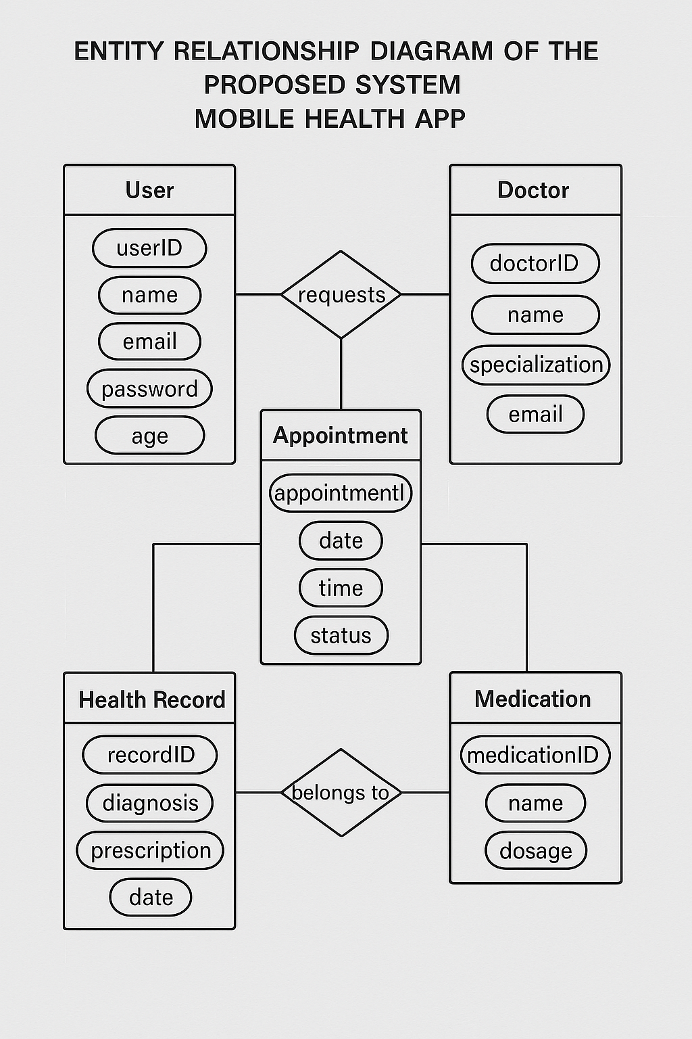

**CLASS DIAGRAM OF PROPOSED SYSTEM  
MOBILE HEALTH APP**

**User**

- userID: Int   
- name: String   
- email: String   
- password: String   
- age: Int   
- healthData: String

+ register()   
+ login()   
+ logout()   
+ logSymptoms()   
+ requestAppointment()

**Appointment**

- appointmentID: Int   
- user: User   
- doctor: Doctor   
- date: DateTime   
- status: String   
  
+scheduleAppointment()  
+ cancelAppointment()   
+ updateStatus()

**Doctor**

- doctorID: Int   
- name: String   
- specialization: String   
- email: String   
  
+ prescribeTreatment()   
+ viewAppointments()   
+ provideHealthAdvice()   
+updateMedicalRecord()

**Medication**

- medicationID: Int   
- name: String   
- dosage: String   
- user: User 

+ requestRefill()   
+ confirmRefill()

**Health Record**

- recordID: Int   
- user: User   
- doctor: Doctor   
- diagnosis: String   
- prescription: String   
- date: DateTime   
  
+ updateRecord()   
+ retrieveRecord()

B. Choose 2 profile entries, 2 main transaction, and 2 report generation of your proposal and create the following designs.

**A. Algorithm**

**2 PROFILE ENTRIES**

## **1. Patient Registration** BEGIN DISPLAY "Enter Name, DOB, Gender, Contact, Email, Password" GET Name, DOB, Gender, Contact, Email, Password VALIDATE inputs IF Email already exists THEN DISPLAY "Error: Email already registered" ELSE SAVE to User Database DISPLAY "Registration Successful!" ENDIF END

## **2. Doctor Profile Management** BEGIN DOCTOR LOGS IN DISPLAY "Enter Specialization, Availability, Contact Info" GET Specialization, Availability, ContactInfo VALIDATE inputs IF valid THEN UPDATE Doctor Profile in Database DISPLAY "Profile Updated Successfully!" ELSE DISPLAY "Error: Invalid Input" ENDIF END

**2 MAIN TRANSACTION**

**1. Appointment Scheduling**  
BEGIN  
 PATIENT LOGS IN  
 DISPLAY "Select Doctor"  
 GET Doctor_ID  
  
 DISPLAY "Choose Available Date and Time"  
 GET Date, Time  
  
 CHECK if Slot is Available  
 IF Slot is Available THEN  
 SAVE Appointment (Patient_ID, Doctor_ID, Date, Time, Status) to Database  
 DISPLAY "Appointment Successfully Scheduled!"  
 ELSE  
 DISPLAY "Error: Slot Not Available"  
 ENDIF  
END

## **2. Medication Reminder** BEGIN DISPLAY "Enter Medication Name, Dosage, Reminder Time" GET MedicationName, Dosage, ReminderTime VALIDATE inputs IF valid THEN SAVE Reminder to Database DISPLAY "Medication Reminder Set Successfully!" ELSE DISPLAY "Error: Invalid Input" ENDIF END

**2 REPORT GENERATION**

## **1. Patient Health Report** BEGIN ADMIN LOGS IN DISPLAY "Select Patient and Date Range" GET Patient_ID, DateRange FETCH Health Records FROM Database WHERE Patient_ID AND Date MATCH DISPLAY "Patient Health Report" FOR EACH Record IN Records DISPLAY Record.Date, Record.Diagnosis, Record.Prescriptions ENDFOR END

**2. Appointment Report**  
BEGIN  
 ADMIN LOGS IN  
 DISPLAY "Select Report Type (Daily, Weekly, Monthly)"  
 GET ReportType  
  
 FETCH Appointments FROM Database WHERE Date MATCHES ReportType  
 DISPLAY "Appointment Report"  
  
 DISPLAY "Total Appointments:", COUNT(Appointments)  
 DISPLAY "Completed Appointments:", COUNT WHERE Status = 'Completed'  
 DISPLAY "Cancelled Appointments:", COUNT WHERE Status = 'Cancelled'  
END

**FLOWCHART OF THE PROPOSED SYSTEM**

**MOBILE HEALTH APP**

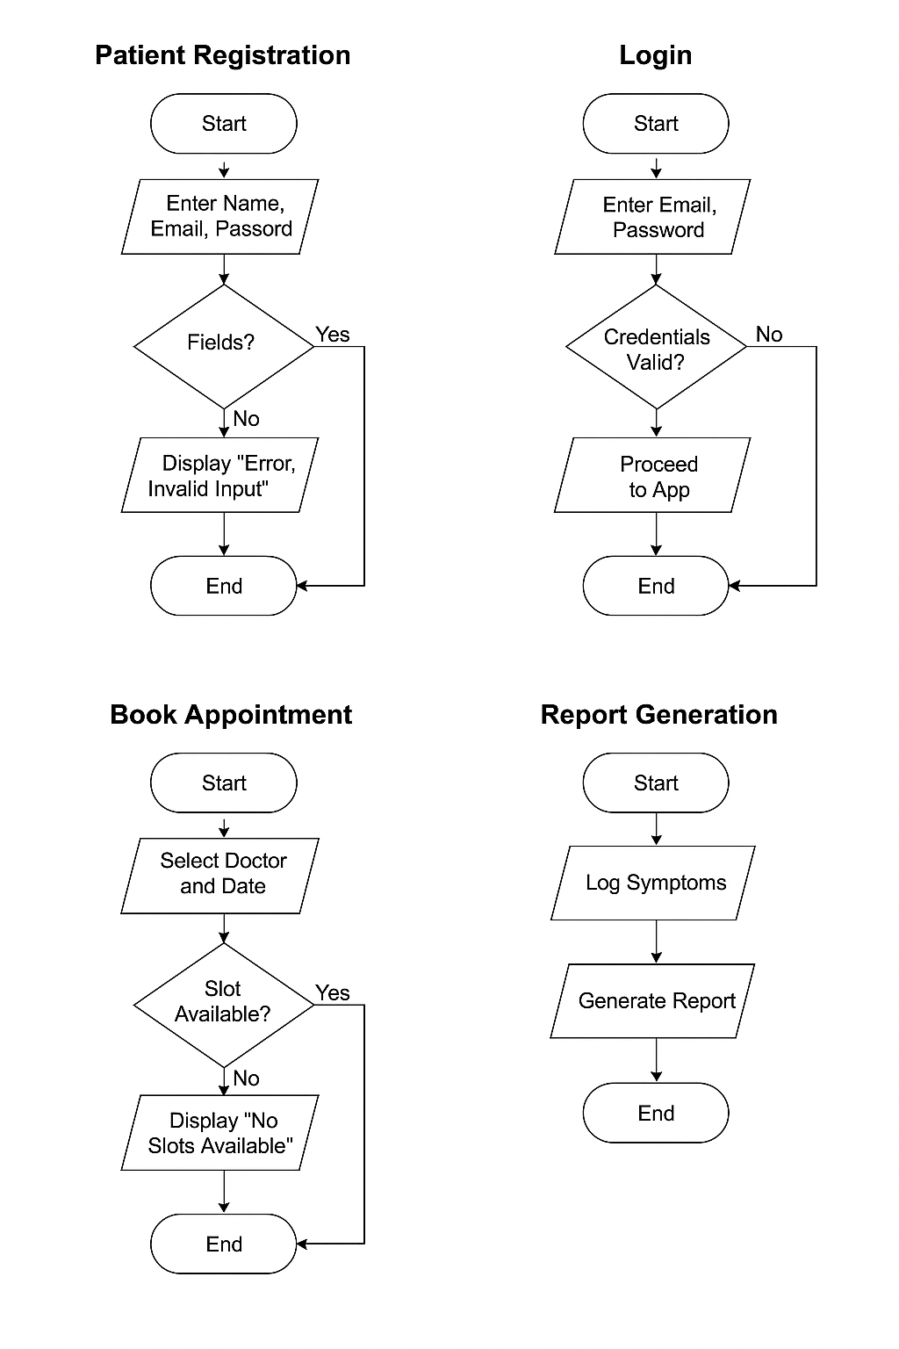

**Wireframe Mobile health App**

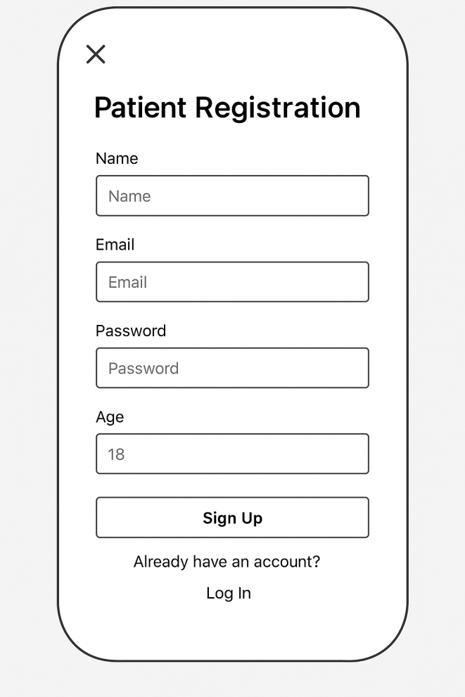

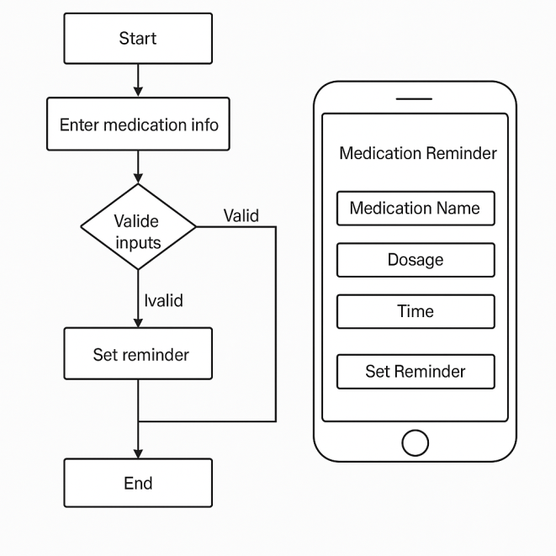

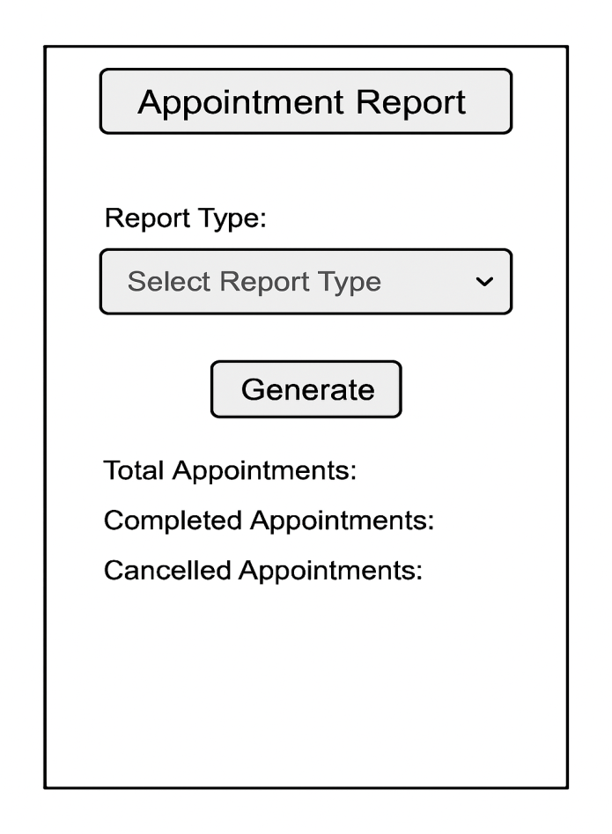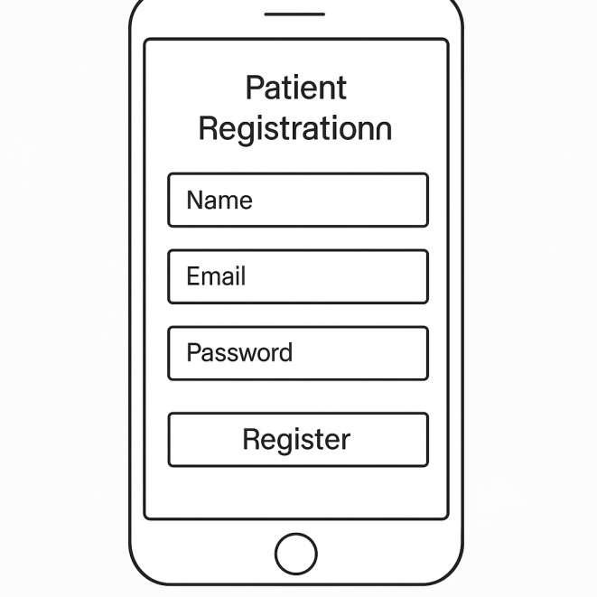

Appointment Report Viewer for Admin

Alternate 2D Mobile Registration Screen